KUSUM AGRAWAL (name changed) came to meet our **gastrointestinal surgeon, Dr. MUKUND JOSHI** with the following complains**:**

1. Severe pain in upper right and centre of her abdomen.
2. Tenderness in her abdomen, particularly in her right upper quadrant.
3. Nausea and vomiting.

She also complained of chest pain. Suspecting Gall Bladder stone, Dr. JOSHI did some blood test and special test to check her Bile Ducts for Gallstone.

A **GALLSTONE** is a stone formed within the gallbladderout of bile components. The term cholelithiasis may refer to the presence of stones in the gallbladder or to the diseases caused by gallstones. Gallstones are formed in the gallbladder, typically from either cholesterol or bilirubin.

**Causes of GALLSTONE are-**

* The stones form when the amount of cholesterol or bilirubin in the bile is high.
* Other substances in the bile may promote the formation of stones.
* Pigment stones form most often in people with liver disease or blood disease, who have high levels of bilirubin.
* Poor muscle tone may keep the gallbladder from emptying completely. The presence of residual bile may promote the formation of gallstones.

Dr. Joshi also advised her to avoid high fat foods like Fried foods, like French fries and potato chips, high fat dairy products like cheese, ice cream, pizza, creamy soups or sauces, meat.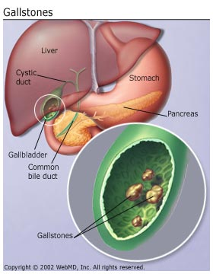 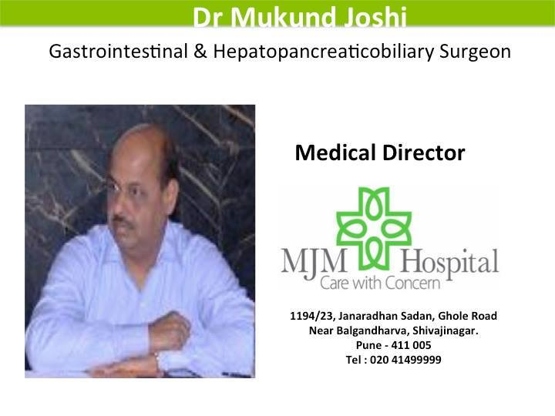v 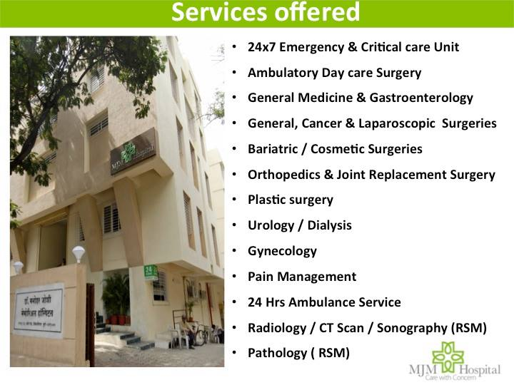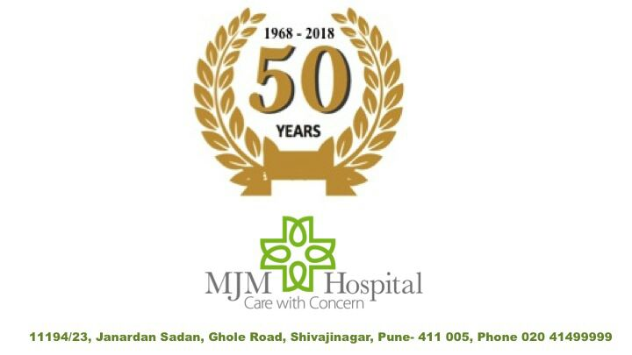m,mMJM HOSPITAL runs “**GASTROENTOROLOGY CLINIC**” in their hospital at Ghole Road, PUNE. The hospital is instrumental in reducing GALL BLADDER STONE problems in hundreds of patients.